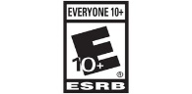Game Title: **KEPLER-ZERO**

Intended Game System: Windows, X-BOX ONE, PlayStation

Target Ages: 10+

Intended Entertainment Software Rating: E10+

Gameplay:

The planet is dying! The last solar flare to end all matter on earth is t-minus 3 hours. You are the captain, create your avatar as you blast off with your team to space to reach the nearest habitable planet Kepler-Zero. This space simulator RPG game will take you to uncharted regions filled with unpredictable challenges as they make their way to their final destination Kepler-Zero.

Distinct modes of gameplay:

Simulation Mode

Players must navigate their way through space using the resource they have to defend and attack nearby threats, including asteroids, space debris, and other spaceships.

Exploration Mode

The player will occasionally will have to drop to other planets to replenish resource where they will have to gather food supplies, and make repair, all while defending their ships from extra-terrestrials.

Unique Selling point:

* Different planets to explore
* Defeat masses of aliens
* Discover new and exotic produce
* Manage your own space craft and shoot asteroids with laser

Competitive Products:

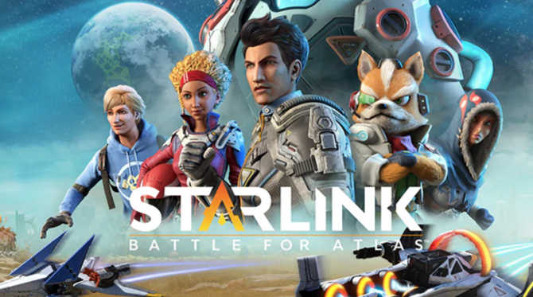 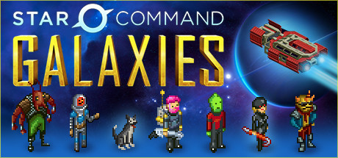

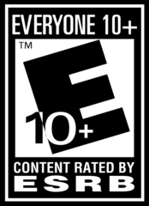Game Title: Nose Jam

Intended Game System: Windows, Android

Target Ages: 10+

Intended Entertainment Software Rating: Everyone 10+

Gameplay:

You play as a pathogen that entered the human body through the nose. The main objective is to plug up nose so the human can’t breathe before they try to blow their nose. The pathogen is equipped with different harmful bacteria to infect the surrounding cells to create mucus to plug up the nose. Depending on the host body the player is faced with different challenges like fighting of anti bacterial cells, breaking through immunity shields, and body configurations.

Distinct modes of gameplay: Multiplayer

Queue with other players and compete to see who can plug up the nose first. Player have the option to destroy, take over, and infect other players created mucus to best compliment their strategy to win the game.

Unique Selling point:

* Creating different bacteria
* Defeating cells
* Infecting the human body

Competitive Products:

 

Game Title: The Tear of Blood

Intended Game System: PS4, Windows, X-BOX ONE

Target Ages: 17+

Intended Entertainment Software Rating: M17+

Gameplay:

The day had finally come. You assume the role of the hero in this RPG vampire world. Choose and customize your avatar as you travel the world unlocking new skills, and creating weapons and armour to make your character stronger. The player will be taken to different towns where he has to defeat the vampires to free the people. The player’s ultimate goal is to reach the vampire’s kingdom where the vampire king lives.

Distinct modes of gameplay:

Exploration mode:

The character have the option to acquire sub quest from the NPC’s, take bounties, gather supplies, and train combat skills by killing enemies. The player can use the gold they collected buy and sell items and equipment’s in local stores to aid their character progress through the game.

Multiplayer mode:

Players can join their friends on a siege adventure to capture the castle by defeating all the enemies and bosses. The leader of the party will have the option to choose difficulty of the siege which will in turn changes the ward output that the player can use to make the character stronger. Rewards include weapons, armour, upgrade materials, potions and abilities.

Unique Selling point:

* Unlockable skill traits
* Ability to craft armour and weapons
* 3-D battle mechanics
* Defeating legendary foes
* Open-world exploration

Competitive Products:

 

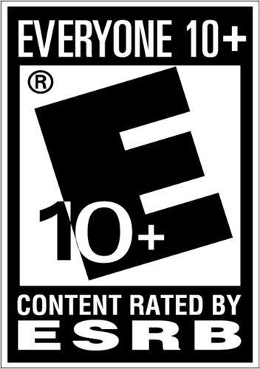Game Title: Nomad Uprising

Intended Game System: PS4, X-BOX One, Windows

Target Ages: Teens

Intended Entertainment Software Rating: E10+

Gameplay:

The earth was barren, nothing but dust and sand everywhere you look. The player can choose from 5 different rivaling nomad clans. Depending on what clan the player chooses, it will effect their starting point in the game. The different clans are spread out across a single shared map where every clan can encounter and fight each other. In this real-time co-op online, multiplayer strategy game players must work together to gather resources, conquer bases, and defeat other clans, to reach the castle in the middle of the map to claim the crown. Once a clan claims the crown they will hold the title of the king of nomads and now have to defend their castle from other clans trying to over throw them.

Unique Selling point:

* Character customization
* Co-operative Gameplay
* Competitive Gameplay

Competitive Products:

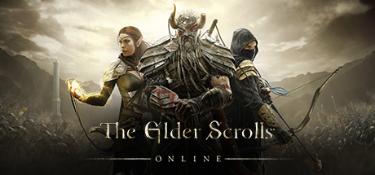

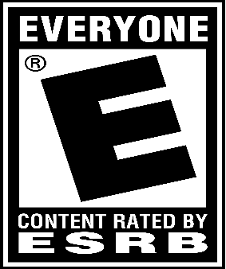Game Title: Boar Destruction

Intended Game System: Mobile

Target Ages: Everyone

Intended ESRB rating: E

Gameplay:

You play as a deranged boar who just escaped from a kennel. The boar has to dodge obstacles, run over people and collect power ups to help stay in the game. In this 2-D mobile platform game you earn points by the amount of people you run over. As the boar progress through the map, the background will change and the boar will start moving faster making it hard to maneuver and dodge. When the boar hits an obstacle the game will be over. The boar can collect power ups like extra health, invincibility, and point boosters which are randomly placed on the maps to help players gain more points.

Distinct modes of gameplay: Single player

Unique Selling point:

* Easy to play
* Customizable character
* Different backgrounds Setting

Competitive Products:

